**A B.Tech. Project Report**

on

**GESTURE RECOGNITION AND HAND MOVEMENT TRACKING IN REAL TIME**

*Submitted in partial fulfilment of the requirements for the degree of*

**Bachelor of Technology**

**(Computer Science and Engineering)**

by

|  |  |  |
| --- | --- | --- |
| **Syed Alfran Ali** | **Shams Ali** | **Jai Pal Singh** |
| **(2015KUCP1032)** | **(2015KUCP1034)** | **(2015KUCP1038)** |

Under the Supervision of

**Ashish Sharma**



**Department of Computer Science and Engineering**

**Indian Institute of Information Technology Kota**

**(India)**

**2015-2019**

# Declaration

We hereby declare that the work reported in the B. Tech report entitled “Gesture Recognition and Hand Movement Tracking in Real Time” submitted at Indian Institute of Information Technology, Kota India, is an authentic record of our work carried under the supervision of Ashish Sharma. We have not submitted this work elsewhere for any other degree.

Syed Alfran Ali

(2015KUCP1032) ……………………………….

Shams Ali

(2015kucp1034) ……………………………….

Jai Pal Singh

(2015KUCP1038) ……………………………….

Dept. of CSE

IIIT, Kota

# Certificate

This is to certify that the report entitled, “Gesture Recognition and Hand Movement Tracking in Real Time” which is being submitted by Syed Alfran Ali, Shams Ali and Jai Pal Singh in fulfilment for the award of degree of B. Tech in Computer Science and Engineering by the Indian Institute of Information Technology, Kota, is the record of candidates own work carried out by them under my supervision. This work has not been submitted partially or wholly to any other University or Institute for the award of this or any other degree.

Ashish Sharma ……………………………….

Dept. of CSE

IIIT, Kota

# Acknowledgements

We are profoundly grateful to Ashish Sharma for his expert guidance and continuous encouragement throughout to see that this project rights its target since its commencement. His timely and efficient contribution helped us shape our work into its final form and we express our sincerest gratitude for his assistance in any way that we may have asked. We appreciate his guidance in our project that has improved our project many folds, thanks for the comments and advise.

We would also like to thank all other faculty members of IIIT Kota for their direct or indirect supports and advise without which this project would not have been possible.

Syed Alfran Ali

Shams Ali

Jai Pal Singh

# Abstract

As technology has become one of the most important part of the day to day human life, so in order to make the best use of those technologies the study of the relationship and interaction between human and computer i.e. called human computer interaction (HCI) is important. In this way, with the help of human computer interaction, we can develop and improve computer system to serve the needs of human in a better and efficient way. Human computer interaction can be applied in various fields and research areas as like in medical system which would be beneficial for the elderly people who are not able to walk or talk or express their feelings by words. It is also helpful in the field of computer application where we can make the use of human computer interaction with the help hand gesture recognition to control the mouse cursor and perform different actions accordingly.

In this project we are trying to provide a non-tangible way of human computer interaction and that is with the help of hand movement to control the mouse cursor and perform different actions like single click, scroll function, etc. And for that we are using colour segmentation technique to remove all the unnecessary colour so that the desired colour can be recognised easily and then find contours. Using these contours, we map different mouse operations with different gestures and create a virtual mouse.

**Table of Contents**

Declaration ii

Certificate iii

Acknowledgements iv

Abstract v

List of Figures viii

List of Flow Charts ix

Symbols x

Abbreviations xi

Introduction 1

1.1 Computer Vision 1

1.2 Gesture Recognition 1

1.3 Human Computer Interaction 2

1.4 Hand Gesture Recognition 2

1.5 Object Detection 2

1.6 Object Movement Tracking 2

1.7 Importance of Human Computer Interaction 3

Motivation and Objective 4

2.1 Motivation 4

2.2 Objective 4

Literature Survey 6

3.1 Gesture Recognition and fingertip detection for HCI 6

3.2 The Vision-Based Hand Gesture Recognition Using Blob Analysis 7

3.3 Real-Time Marker-Based Finger Tracking with Neural Networks 7

3.4 Real Time Hand Gesture Movements Tracking and Recognizing System 8

3.5 An Efficient Fast Hand Tracking Approach based on Segmentation 8

3.6 The Application of Improved Camshift Algorithm in Hand Tracking 9

3.7 Tracking Hand Movements and Detecting Grasp 9

Problem Statement 11

Methodology 12

Experimental Results and Discussion 17

6.1 Experimental Results 17

6.2 Discussion 18

Applications 19

Conclusion 20

Future Work 21

References 22

# List of Figures

Figure 1 - Number of publications v/s Year 3

Figure 2 - (a)Webcam image, (b)raw mask, (c)open mask and (d)close mask for single object detection 14

Figure 3 - (a)Webcam image, (b)raw mask, (c)open mask and (d)close mask for multiple object detection 14

Figure 4 - Open gesture recognition 17

Figure 5 - Close gesture recognition 18

# List of Flow Charts

Flow Chart 1 - Colour Segmentation and Object Detection 13

Flow Chart 2 - Object tracking and Mouse binding 15

# Symbols

|  |  |
| --- | --- |
| $$x1$$ | x-coordinate of first detected object in Open gesture |
| $$y1$$ | y-coordinate of first detected object in Open gesture |
| $$w1$$ | Width of first detected object in Open gesture |
| $$h1$$ | Height of first detected object in Open gesture |
| $$x2$$ | x-coordinate of second detected object in Open gesture |
| $$y2$$ | y-coordinate of second detected object in Open gesture |
| $$h2$$ | Width of second detected object in Open gesture |
| $$w2$$ | Height of second detected object in Open gesture |
| $$cx1$$ | Centre x-coordinate of first detected object in Open gesture |
| *cy1* | Centre y-coordinate of first detected object in Open gesture |
| *cx2* | Centre x-coordinate of second detected object in Open gesture |
| *cy2* | Centre y-coordinate of second detected object in Open gesture |
| *cx* | Centre x-coordinate of the line drawn |
| *cy* | Centre y-coordinate of the line drawn |
| *x* | x-coordinate of the detected object in Close gesture |
| *y* | y-coordinate of the detected object in Close gesture |
| *w* | Width of the detected object in Close gesture |
| *h* | Height of the detected object in Close gesture |

# Abbreviations

|  |  |
| --- | --- |
| HCI | Human Computer Interaction |
| HSV | Hue, Saturation, Value |
| IK | Inverse Kinematics |
| LSTM | Long Short-Term Memory |
| RNN | Recurrent Neural Network |
| SVM | Support Vector Machine |

**Chapter 1**

# Introduction

In the present world, the interaction with the computing devices has advanced to such an extent that as humans it has become necessity and we cannot live without it. The technology has become so embedded into our daily lives that we use it to work, shop, communicate and even entertain our self. It has been widely believed that the computing, communication and display technologies progress further. To efficiently use them, most computer applications require more and more interaction. For that reason, human-computer interaction (HCI) has been a lively field of research in the last few years. Recognizing hand gestures for interaction can help in achieving the ease and naturalness desired for human computer interaction.

## Computer Vision

Computer vision is a field of computer science that is entrusted with how computers can gain high level understanding from digital images or sequences of digital images or videos. In other words, we can say that it provides computers the ability to analyse and understand useful information from digital images or sequence of images or videos. Actually, computer vision gives computers the ability to see or visualise things in the same way as we see or visualise things through human vision. Computer Vision provides us with an opportunity to make the best and efficient use of the computer technologies and improve the computer system to serve the various human needs.

## 1.2 Gesture Recognition

Gesture recognition is the branch of computer science that deals with the mathematical interpretations of the human motion with the help of a computing device. The origin of the gesture can from any part of the body but most commonly its origin is either face or hand. In simple words we can say that gesture recognition is used to recognise and identify the movements of the different parts of the human body. The most common gesture recognitions are hand gesture recognition, face recognition, facial expression recognition etc. Gesture recognition is one of the best ways of interaction with the computer system.

## Human Computer Interaction

Human computer interaction is the branch of computer science that deals with the relationship and interaction of the human with computer system. In simple words we can say that it enables computers to interact with the humans in the similar way as humans interact with humans. Human computer interaction can be done in many ways as like through hand gesture recognition, voice recognition, speech recognition, face recognition, facial expression recognition etc. In fact, we can say that human computer interaction is laying the foundation of a future where humans and computers would be related to or linked with each other as they were never before.

* 1. Hand Gesture Recognition

Hand gesture recognition is considered as one of the best interaction style and non-tangible technique for human computer interaction. In this technique different hand gestures are recognised using some algorithm like convex-hull etc. and certain actions are being performed based on those gestures. Hand gesture can be categorised into two types of hand gesture representation:

1. Contact Based: In contact-based hand gesture representation, the hand must be in contact with some of the external device as like gloves for the gesture to be recognised. Without the external device contact-based hand gesture representation is meaningless.
2. Vision Based: In vision-based hand gesture representation the hand need not to be in contact with some external device to recognise the gesture. The only requirement for this type of hand gesture representation is that you need a computer inbuilt with camera or computer system with camera.

* 1. Object Detection

Object detection is a process of finding or detecting instances of real-world objects such as human, buildings or cars etc. in images or videos. It is a computer technology related with computer vision and image processing. Object detection has been widely used for face detection, vehicle detection, pedestrian counting, web images, security systems and driverless cars. There are many ways object detection can be used as well in many fields of practice. Like every other computer technology, a wide range of creative and amazing uses of object detection will definitely come from the efforts of computer programmers and software developers.

* 1. Object Movement Tracking

Moving object detection is to recognize the physical movement of an object in a given place or region. By acting segmentation among moving objects and stationary area or region, the moving objects motion could be tracked and thus could be analysed later. To achieve this, consider a video is a structure built upon single frames, moving object detection is to find the foreground moving target(s), either in each video frame or only when the moving target show the first appearance in the video. Moving objects detection has been used for wide range of applications like video surveillance, human activity analysis, road condition monitoring, airport safety, monitoring of protection along marine border and etc.

* 1. Importance of Human Computer Interaction

As we all know that human computer interaction deals with how humans and computers interact and how they are related to each other. So, the study of human computer interaction is important because if we want to improve the computer system to serve the human need, we must know about how they are related with each other also how they interact with each other. Human computer interaction has gained its importance and has become one of the most interesting domains for the researchers to work on such related topics. Over the past few decades the number of publications on the topic related with human computer interaction has increased exponentially and also it is increasing day by day.

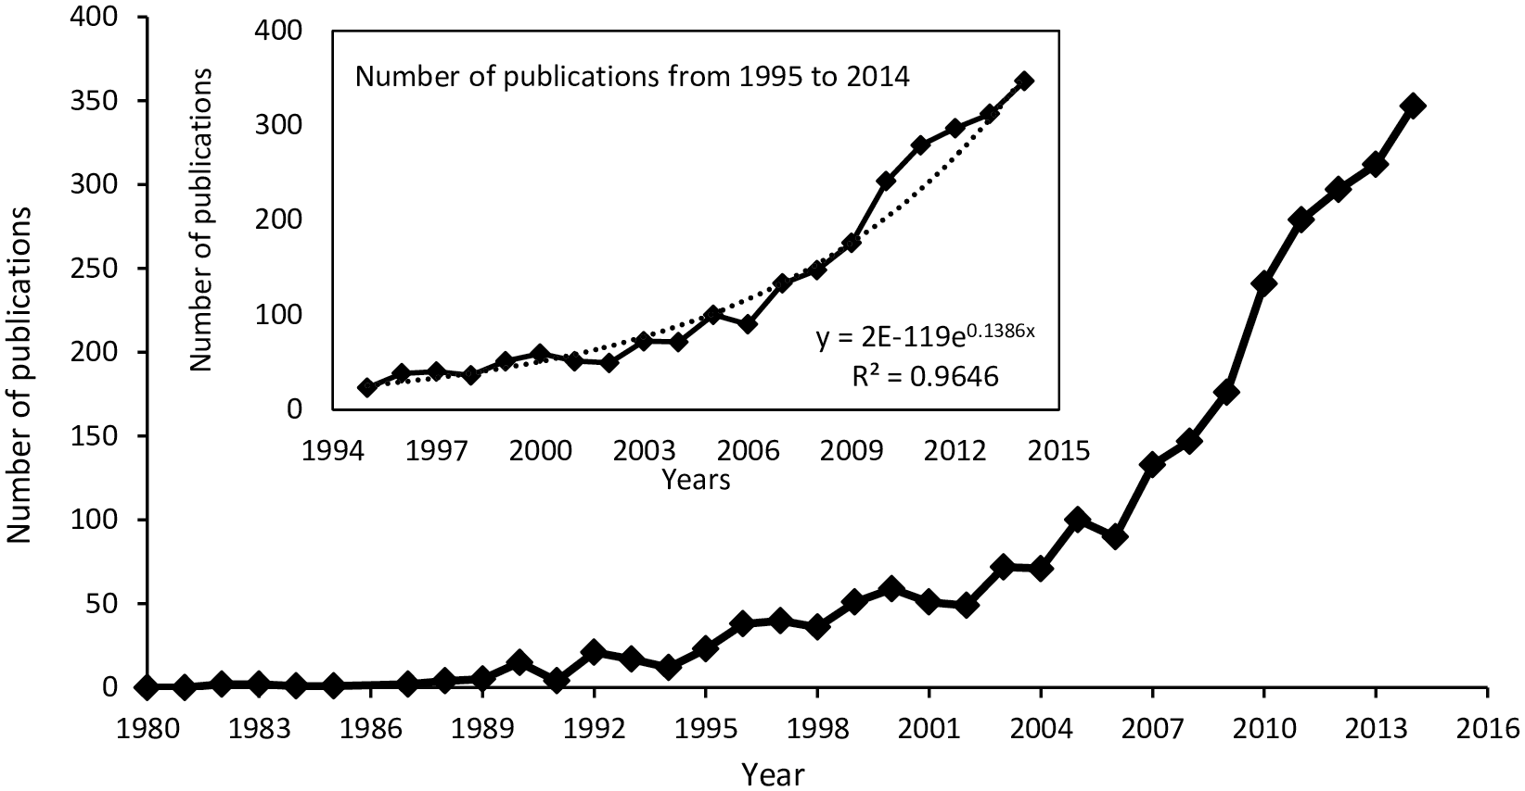

*Figure 1 - Number of publications v/s Year* [1]

**Chapter 2**

# Motivation and Objective

## 2.1 Motivation

The motivation behind this project is as follows:

1. To provide and improve the existing non-tangible (without being in contact) way of HCI using hand gesture recognition. So, in this project we are using vision-based hand gesture representation technique to improve the computer to serve the human need.
2. Vision based hand gesture representation is helpful for elderly people as well as for those people who are not able to speak or express their feelings through words because we can use those gestures and bind some action related to those gestures so that they can be performed when recognised without any difficulty.
3. This area of research is useful for various other research areas as like it would be useful in the field of medical science, speech recognition, and other research areas where human body motion and gestures are combinedly being analysed.

## Objective

The goal of our project is to control mouse operations with the help of hand gestures. We have set the following objectives for our virtual mouse to achieve the goal:

1. In order to achieve the above stated objective first we need to develop a model that can recognise different hand gestures according to the need.
2. And in order to recognise different hand gestures first we need to create and define hand gestures that we want to use in our project.
3. Then we need to implement that model using appropriate algorithms that can increase performance and efficiency of the mouse operations through hand gestures.

**Chapter 3**

# Literature Survey

For the approaches used in developing algorithm of the hand gesture recognition and user interaction system, there are various techniques implementing for detecting and tracking the dynamic hand gestures such as Haar-like features [2], convex hull [3], contour matching [4], and skin colour [5]. Here is the literature we went through to gain knowledge about this field.

## 3.1 Gesture Recognition and fingertip detection for HCI [6]

The paper proposes a novel gesture recognition and fingertip detection algorithm for Human Computer Interaction in particular mouse control operations using real time camera. The hand gestures are captured using real time camera**.**

**Algorithm:**

Authors have used region growing algorithm followed by morphological operations to segment hand region. The centroid of the palm region is calculated and the finger tips are then detected using the convex hull algorithm.

The proposed method is tested on five different gestures and the results prove that the gestures are able to be recognized and the finger tips detected. The method can be applied for hand gesture-controlled mouse operations**.**

**Result:**

1. Region growing methods can correctly separate the regions that have the same properties we define.
2. It can provide the original images which have clear edges with good segmentation results.

**Limitation:**

This algorithm is computationally expensive and is sensitive to noise.

## 3.2 The Vision-Based Hand Gesture Recognition Using Blob Analysis [7]

The paper proposes that human-computer interaction (HCI) can be applied in various areas including medical system and the development of algorithm by using hand gestures**.**

**Algorithm**

This paper proposes a dynamic hand gesture recognition algorithm for elder people. The algorithm implements in a vision-based hand gesture recognition using optical flow and blob analysis to track six dynamic hand gestures and classify their meanings.

**Result:**

The experiment provided good results for all six hand gestures in detection, tracking, and classification procedures. Also, no other external device is required except web camera which is generally available to all.

This technique includes high flexibility and excellent performance.

**Limitation:**

This technique requires clear background-foreground relation and high pixel-precision.

## 3.3 Real-Time Marker-Based Finger Tracking with Neural Networks [8]

Although marker-based motion capture with inverse kinematics (IK) works for body tracking, it is less reliable for fingers often occluded when captured with cameras. Many computer vision and virtual reality applications circumvent the problem by using an additional system (e.g. inertial trackers). We explore an alternative solution that tracks hands and fingers using solely a motion capture system based on cameras and active markers with machine learning techniques**.**

**Algorithm**

The animation of fingers is performed by a predictive model based on neural networks, which is trained on a movements dataset acquired from several subjects with a complementary capture system (inertial)

**Result:**

The system provides a natural reconstruction of the hands in most real-case scenarios. This data-driven approach to inverse kinematics does not require defining a set of rules or constraints, as these are learned automatically from the data. Occlusions are corrected with good accuracy in most cases, and with minimal latency.

**Limitation:**

This technique shows discontinuities which can be corrected using Recurrent Neural Network (RNN) without explicit corrections like LSTM (long short-term memory) which can keep track of long contexts.

## 3.4 Real Time Hand Gesture Movements Tracking and Recognizing System [9]

Vision-based hand gesture recognition is a challenging problem, which involves complex computation, due to high degree of freedom in human hand. In this paper, authors use hand gesture captured by web-cam instead of mice, for natural and intuitive human-computer interaction.

**Algorithm**

This paper uses skin detection method to create a segmented hand image and to differentiate with the background. A contours and convex hull algorithm are used to recognize hand area as well as the number of fingertips of hand gesture image to be mapped with button. Moreover, for detection of hand gesture motion, Lucas-Kanade pyramidal algorithm is used.

**Result:**

The system can recognize and track the hand movement and can replace the mouse function to move the mouse cursor and the mouse click function as well.

The segmentation algorithm using skin colour detection is good enough to separate the hand image with its background. The convexity defect algorithm can work well in detecting the number of user’s hand, to replace the mouse click functions.

In general, the system can detect and follow the hand movement so that can be used as user interface in real time.

**Limitation:**

This technique requires to improve segmentation process in eliminating the effect of illumination changes. It is possible to use another colour space such as HSV to minimize the effect of illumination changes.

## 3.5 An Efficient Fast Hand Tracking Approach based on Segmentation [10]

The paper tackles the challenging problem of hand gesture tracking with 2D webcams, which is a promising enabler for human computer interaction. Recent studies have proposed many methods for object tracking. However, unlike the other objects, the particularities of hand make it difficult to be represented by common-used feature descriptors. This paper analyses the key points in hand tracking and take a different approach to address it.

**Algorithm**

The paper contributes:

1. a hand tracking method based on segmentation with colour and movement cues,
2. simplify the histogram-based segmentation method to meet the speed requirement, and
3. a pre-processing method based on colour ranking, to speed up the detection procedure**.**

**Result:**

Along with histogram-based segmentation method, movement cue and colour knowledge from the previous frame are used to contribute to tracking and achieve similar or better performance compared to state-of-the-art methods.

**Limitation:**

There still exists very large improvement space for our method. Authors are studying a better model of cues’ combination to make it more robust and trying optimizations to speed it up.

## 3.6 The Application of Improved Camshift Algorithm in Hand Tracking [11]

Camshift algorithm is often used in hand tracking. The traditional Camshift algorithm can realize hand tracking in simple condition, but it is easy to fail to track when similar colour background interference and occlusion happens. In order to solve the problem, a kind of improved Camshift algorithm is proposed in this paper.

**Algorithm**

The paper proposes a new method to improve Camshift algorithm in which background subtraction algorithm based on mixed gaussian model is used to extract movement information of hand, then combine the colour feature with movement feature by adopting an adaptive method to improve the algorithm. In the meantime, the Kalman filter algorithm is used to predict the location of hand, so the hand can be tracked accurately when it is covered.

**Result:**

Experiment results show that the improved Camshift algorithm can accurately track the hand under the condition of similar colour background and occlusion. And it improves the stability and robustness of hand tracking.

**Limitation:**

This technique requires clear background-foreground relation with similar colour background and occlusion. Without them, tracking become difficult and accuracy decreases drastically.

## 3.7 Tracking Hand Movements and Detecting Grasp [12]

In this paper, a real-time method for interaction between human and computer is explored which utilizes Microsoft Kinect to measure hand movements and detect grasp gesture. This approach could be integrated into a computer game which, for instance, simulates the pick and place exercise during rehabilitation of individuals with stroke.

**Algorithm**

The hand’s binary image and its corresponding depth data were collected using Kinect. Then a SVM [13] classifier was trained to detect grasp gesture. Trained model was tested online for classifying grasp and non-grasp hand gestures.

**Result:**

The experiment shows using Kinect, the hand movement and its direction can be detected in 3D space. This technique includes high flexibility and excellent performance for grasping gestures.

Trained model was tested online for classifying grasp and non-grasp hand gestures using Kinect. The trained model was able to detect grasp gesture with 89.1% accuracy.

**Limitation:**

Although the system can provide some promising result, it still has some limitations. The main challenge is detecting non-grasp gestures, as it has more various shapes than grasp gesture, which can result in false result.

**Chapter 4**

# Problem Statement

As the name suggests, the objective of our project is to recognise various hand gestures and track them in real time. Then, utilize the recognized gesture to bind them with mouse operations and thus create a virtual mouse. Therefore, the problem statement for our project is “to track hand gesture movement in real time and bind those gesture with mouse”.

For the completion of some task, there are some particular steps that are needed to be followed. Same is the case for our project. The steps that we are going to follow are:

* develop a model that recognises the hand gesture
* track the movement of hand gesture
* bind the movement of hand gesture with mouse cursor

We are very sure that after following these steps, we can create a system that can recognise various hand gestures, track them and perform basic mouse operations in real time. In this project, we aim to perform all the actions that are possible by dragging mouse and single clicking.

**Chapter 5**

# Methodology

In this project, we propose a method to create a virtual mouse using colour segmentation and gesture recognition. This can be done in two steps. First, we will do simple colour detection to detect some coloured objects and mark them in live camera view. Secondly, we will do gesture recognition and mouse function binding on top of that.

Object detection using colour segmentation consists of a series of steps. These steps are shown in flow chart 1. We start from reading frame from the camera and then we will resize it to make it a small fixed size for faster processing. Now we will convert this image to HSV format. We only want green colour object to be detected, rest of the colours we are not interested in. To do that we need to decide a range for HSV value for coloured object. So, we declared some limits for the HSV values of each pixels. Now we will create a new binary image of same size a original image, we will call it mask. Mask will contain only those pixels that are in this HSV range.

In the raw mask, there can be some false-positives or noises which are not good for object tracking. To make the tracker work, we need to clean the mask using some morphological operations namely:

a) Opening:to remove all the dots randomly popping here and there in the mask.

b) Closing:to close the small holes that are present in the actual object.

Figure 2 and Figure 3 shows web-cam image, raw mask, mask after open morphological operation and mask after close morphological operation for one 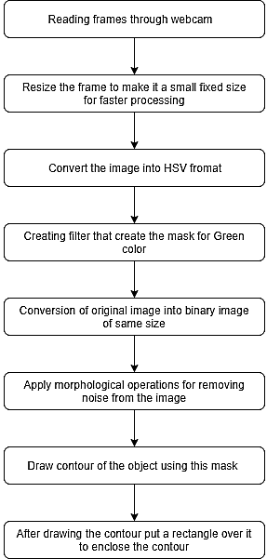and two objects. We are using the result of close mask as the final form of image. Now we know exactly where the object is so we can draw a contour from this mask. We will keep count of number of contours and draw a rectangle around each contour for easy detection. This is all to be done in first step.

*Flow Chart 1 - Colour Segmentation and Object Detection*

In second step to create a virtual mouse with gesture recognition, we first need screen resolution and captured image resolution. All the steps for this are shown in flow chart 2. From the number of contours detected, we have to decide the gesture for each number of contours. We are implementing open gesture if two contours are detected and close gesture if only one contour is detected.

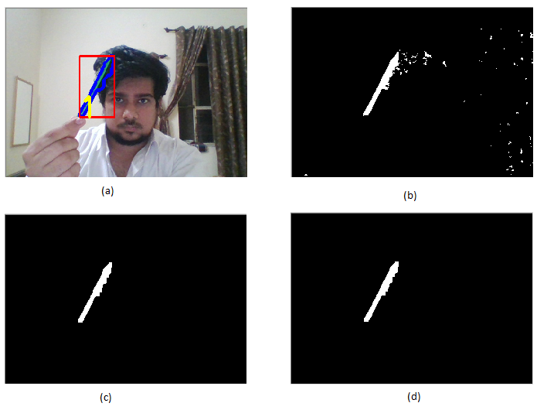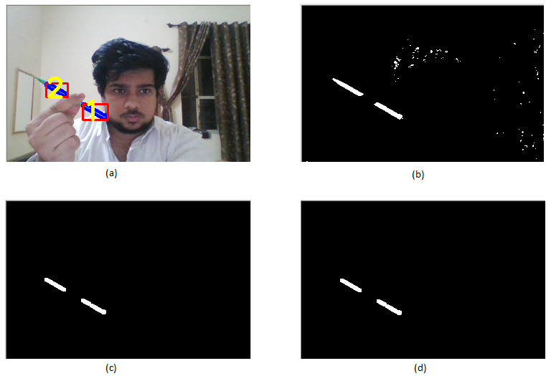

*Figure 2 - (a)Webcam image, (b)raw mask, (c)open mask and (d)close mask for single object detection*

*Figure 3 - (a)Webcam image, (b)raw mask, (c)open mask and (d)close mask for multiple object detection*

*Flow Chart 2 - Object tracking and Mouse binding*

In the contours detected, we have to find a single point that we can bind with the mouse position. There are various ways to find that point. We are using the centre point of the detected contours to draw a line and the mid-point of that line is used to bind with the current location of mouse. We are using the mid-point as it gives least fluctuation in mouse pointer location.

 Open Gesture Operation:Open Gesture is mainly used to simulate mouse drag operation on the screen. To implement the open gesture, we need to do some calculation to find some coordinates. Firstly, we have to calculate the centre of both detected green objects. We can do this by taking the average of maximum and minimum points of the bounding boxes. Consider $x1, y1, w1, h1$ and $x2, y2, w2, h2$ be the x-coordinate, y-coordinate, width and height of first and second detected object respectively. For the calculation, we are using mid-point of both the detected objects. So, the centre coordinate of the first object will be

$cx1=\frac{x1 + w1}{2}$ and $cy1=\frac{y1 + h1}{2}$

Similarly, the centre coordinate of the second object will be

$cx2=\frac{x2 + w2}{2}$ and $cy1=\frac{y2 + h2}{2}$

Then, we draw line through the centres of the detected objects. The centre of the line drawn is the average of centre coordinate of these objects i.e.

$cx=\frac{cx1 + cx2}{2}$ and $cy=\frac{cy1 + cy2}{2}$

These centre coordinates of the line will act as the position for the mouse cursor. To do this, first we need to convert the detected coordinate from camera resolution to the actual screen resolution and after that we set the position as the mouse location. We are doing a mouse release to ensure the mouse left button is not pressed. This is all for the open gesture.

Close Gesture Operation:Close Gesture is used to simulate the mouse left click operation on the screen. The implementation of close gesture is very similar to the open gesture, but the difference is we only have one object here so we only need to calculate the centre of it.

$cx=\frac{x + w}{2}$ and $cy=\frac{y + h}{2}$

And that will be where we will position our mouse pointer. Also, we are performing a mouse press operation instead of mouse release operation.

**Chapter 6**

# Experimental Results and Discussion

## 6.1 Experimental Results

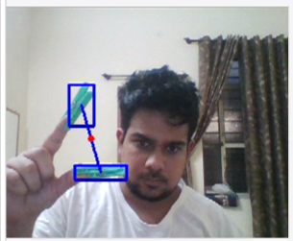To verify the effectiveness of the proposed approach, we have done some testing using I7 1.7 GHz machine and the image sequences are captured at about 30 frames per second.

*Figure 4 - Open gesture recognition*

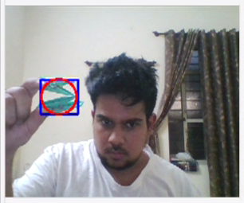

*Figure 5 - Close gesture recognition*

To evaluate the performance of recognition proposed, we examine the system to operate the windows application using hand gesture to replace mouse as user application interface. Testing is done under normal illumination, system can recognize, and track the movement of user hand. The centre of gesture represented by a small circle had successfully follow the user's hand movement.

## 6.2 Discussion

The segmentation process is capable in detecting the user's hand gestures and counting the contours. Figure 4 shows open gesture operation. System is correctly detecting the object on user's hand and is accurately enclosing the detected object in rectangular region. The mouse pointer is moving precisely as the small red dot is moving. Figure 5 shows the close gesture operation. Mouse left click operation is working properly with this operation. We can easily perform the basic window operations such as drag, scroll, select etc.

However, there are some limitations of the program, i.e. the change of lighting environment is still influential in the process of segmentation, in particular on the process of the removal of the background.

**Chapter 7**

# Applications

Most tasks on a computer can be accomplished solely by using the left mouse button. Left-click is often referred to as “normal-click” or “regular-click.” Pressing the left mouse button simulate the mouse cursor being pressed down on the screen which is used to directly interact with files, links and screen items for clicking and dragging. This normal click of mouse has various applications. Some of the applications are listed below:

* Select single or multiple files.
* Drag single or multiply files
* Click on links to open them.
* Minimize, maximize or close a window.

This method of HCI can be applied in various areas such as

* medical system where it can be valuable for the elderly people who are not able to talk or express their feelings by words. The use of a monitoring system with virtual mouse can be beneficial for both elderly and caregivers. With very minute modifications, it can be used in gaming, banking and other areas.
* in ATM’s where a user can select options using the virtual mouse. Since everything is done without touching or clicking anything, this feature can add extra security to the system.
* for gaming purpose where a slight modification can help the player to perform various tasks and enjoy the virtual gaming.

**Chapter 8**

# Conclusion

It can be concluded from the experiments that, due to the particularities of hand, the common-used feature descriptors such as angular points, Haar-like features, histogram-based features and etc, cannot perform well in hand tracking. But by using the above proposed methodology the system can recognize and track the hand movement and can replace the mouse function to move the mouse cursor and the mouse left click function as well.

The segmentation algorithm using colour detection is good enough to detect particular colour in the image and separate it with its background. In general, the system can detect and follow the hand movement and can be used as user interface in real time. Overall, we achieve similar or better performance compared to state-of-the-art methods.

However, there are some limitations. The change of lighting environment is still influential in the process of segmentation, in particular on the process of the removal of the background.

**Chapter 9**

# Future Work

There still exists very large improvement space for our method. We are studying a better model of cues’ combination to make it more robust and trying optimizations to speed it up. The future work is to

1. improve segmentation process in eliminating the effect of illumination changes.
2. to make the mouse right click function work using a different object detection technique.
3. to improves the stability of hand tracking.
4. try to use another colour space such as RGB or CMYK to minimize the effect of illumination changes.
5. implement it for key binding to improve the gaming experience.

By experimenting and making all the required changes, we hope to create a system with no or minimum error.

# References

|  |  |
| --- | --- |
| [1] | P. Nardi, “Structure and Evolution of Mediterranean Forest Research: A Science Mapping Approach,” *Pone,* p. 8, 2016. |
| [2] | C.-C. Hsieh and D.-H. Liou, “Novel Haar features for real-time hand gesture recognition using SVM,” *Journal of Real-Time Image Processing,* vol. 10, 6 2012. |
| [3] | P. Barros, N. T. Maciel-Junior, B. J.T. Fernandes, B. Bezerra and S. M.M. Fernandes, “A Dynamic Gesture Recognition and Prediction System using the Convexity Approach,” *Computer Vision and Image Understanding,* vol. 155, 10 2016. |
| [4] | Y. Ren, X. Xie, G. Li and Z. Wang, “Hand Gesture Recognition with Multi-Scale Weighted Histogram of Contour Direction (MSWHCD) Normalization for Wearable Applications,” *IEEE Transactions on Circuits and Systems for Video Technology,* vol. PP, pp. 1-1, 9 2016. |
| [5] | W. Wang and J. Pan, “Hand segmentation using skin color and background information,” in *2012 International Conference on Machine Learning and Cybernetics*, 2012. |
| [6] | T. Gunasundari, R. M. Prakash, T. Deepa and N. Kasthuri, “Gesture Recognition and finger tip detection for,” in *Innovations in Information, Embedded and Communication Systems (ICIIECS)*, 2017. |
| [7] | T. Ganokratanaa and S. Pumrin, “The Vision-Based Hand Gesture Recognition Using,” *2017 International Conference on Digital Arts, Media and Technology (ICDAMT),* pp. 336-341, 2017. |
| [8] | T. &. H. B. &. B. R. Pavllo, “(Real-Time Marker-Based Finger Tracking with Neural Networks.,” in *2018 IEEE Conference on Virtual Reality and 3D User Interfaces (VR)*, 2018. |
| [9] | R. Hartanto, A. Susanto and P. I. Santosa, “Real time hand gesture movements tracking and recognizing system,” in *2014 Electrical Power, Electronics, Communicatons, Control and Informatics Seminar (EECCIS)*, 2014. |
| [10] | L. Xu, L. Zhang, K. Wang and K. Mei, “An efficient fast hand tracking approach based on segmentation,” in *2016 31st Youth Academic Annual Conference of Chinese Association of Automation (YAC)*, 2016. |
| [11] | W. Wei, L. Zhijun, C. Zhiping, M. Xiaomeng, Z. Rui and Y. Ruo, “The Application of Improved Camshift Algorithm in Hand Tracking,” in *2017 International Conference on Industrial Informatics - Computing Technology, Intelligent Technology, Industrial Information Integration (ICIICII)*, 2017. |
| [12] | R. S. Chegani and C. Menon, “Tracking hand movements and detecting grasp,” in *2016 IEEE Canadian Conference on Electrical and Computer Engineering (CCECE)*, 2016. |
| [13] | M. E. Mavroforakis and S. Theodoridis, “A geometric approach to Support Vector Machine (SVM) classification,” *IEEE Transactions on Neural Networks,* vol. 17, pp. 671-682, 5 2006. |